List of Reagents examined in this report:
Reagent | Lot Number
Cell Lysis | 0000481464
Binding Buffer | 0000487523
Prepared Wash Buffer | 0000485667
50% Ethanol | 0000121067
Reliaprep Reagent | 0000476709
Alkaline Protease | 0000334807
Pro K | 0000488401
Nuclease Free Water (invitrogen) | 2107460
Nuclease Free Water (invitrogen) | 2011411
10 x TE | 164977
Sodium Hydroxide | 20J304019
96% Ethanol | 1923760

The associated equipment:
- HSM 1
The acceptance Criteria for the results being run on that particular equipment
- Mean A260 concentration (ng/ul) > 15 ng/ul
- A260/A280 ratio between 1.60 – 2.04
Results of the quarterly validation
 | A260 concentration (ng/ul) |  | A260/A280 absorbance ratios
Tecan-HSM | Mean | Standard deviation | Mean | Standard deviation
1 | 136.51 | 93.92 | 1.66 | 0.17

Do the quarterly validation results fall within acceptance criteria?
- Yes
  - The mean value of A260 concentration (ng/ul) is > 15 ng/ul and the validation is passed
  - The mean value of A260/A280 absorbance ratio is also within the acceptance range
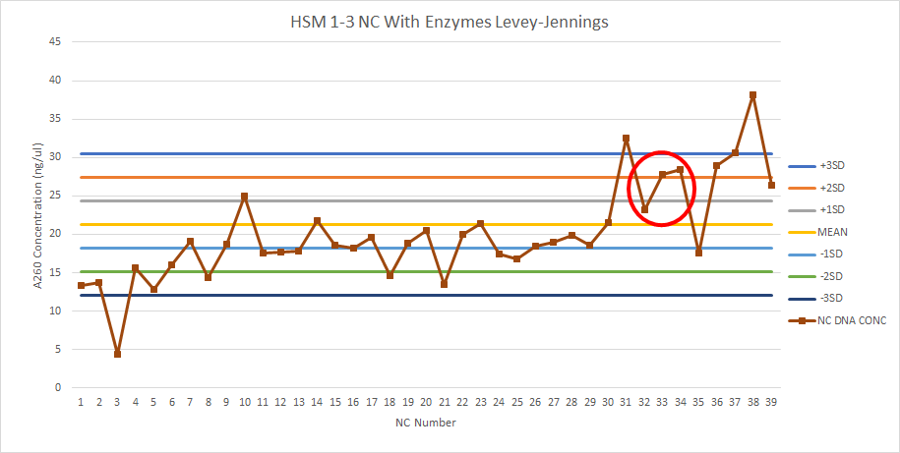

The Negative control values are +/- 3 standard deviation for that batch tested.
Can the reagents mentioned above be signed off as validated?
Yes

